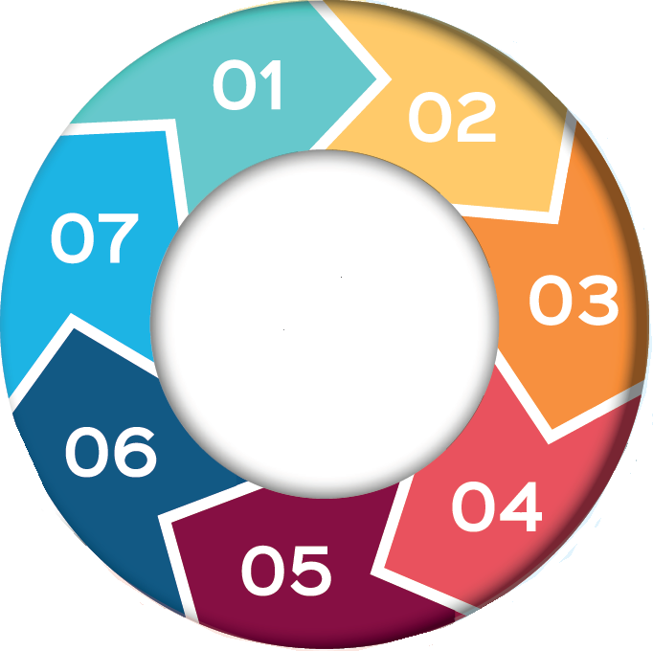
Child Protection Audit

7 Minute Briefing

6.

3

4.

5. Learning Opportunities
3. Methodology

- Purpose of the audit

The Child Protection Audit is undertaken to understand how well current practice across services (Education, Health, Police, and Social Work) identifies, responds to, and supports children at risk of harm.
The audit examines real cases, frontline practice, and multi-agency working to highlight strengths, gaps, and learning that can improve safeguarding outcomes. It aims to ensure that professionals remain vigilant, confident, and supported when concerns about children arise.

2. Why is the audit completed?

-
The child protection audit is carried out twice a year, reviewing 60 case files to check the quality and consistency of safeguarding practice. Regular audits help agencies understand what is working well, identify areas for improvement, and ensure that children remain at the centre of decision-making.

Part one: focuses on agencies reviewing and analysing their own internal single agency information of a case file.
Part two: brings partners together for a multi-agency discussion to examine the collective findings and agree key learning using the care inspectorate framework.

What does the audit tell us?
The audit identifies strengths, areas for improvement and emerging themes in safeguarding practice - Common themes include:
- Keeping the child at the centre.
- Evidencing the child's voice and lived experience.
- Strong professional analysis and judgement.
- Effective use of chronologies and assessment tools.
- Consistent multi-agency communication and decision-making.

The audit process provides valuable learning opportunities for all agencies involved. It highlights areas where practice can be strengthened and areas for improvement. It also reinforces the importance of early identification of risk, collaborative working, and keeping the child at the centre of all decision-making.
Audit learning supports continuous improvement by strengthening child-centred practice, professional analysis, recording quality and multi-agency working. Or Audit learning helps practitioners reflect, develop and strength practice.

.

-

"How audit findings make a difference"
Audit findings are not simply recorded; they are translated into action. Learning from audits drives improvement plans in training, guidance and service development, helping improve outcomes for children and young people.
.

-

7.

"Why it matters"
By reviewing real practice together, agencies identify opportunities for improvement and strengthen collective responsibility leading to better outcomes for children and young people.
“Did you know” - something about thematic exploration – peer on peer offending etc, helping agencies understand emerging risk and target improvement work…not sure it goes here though

