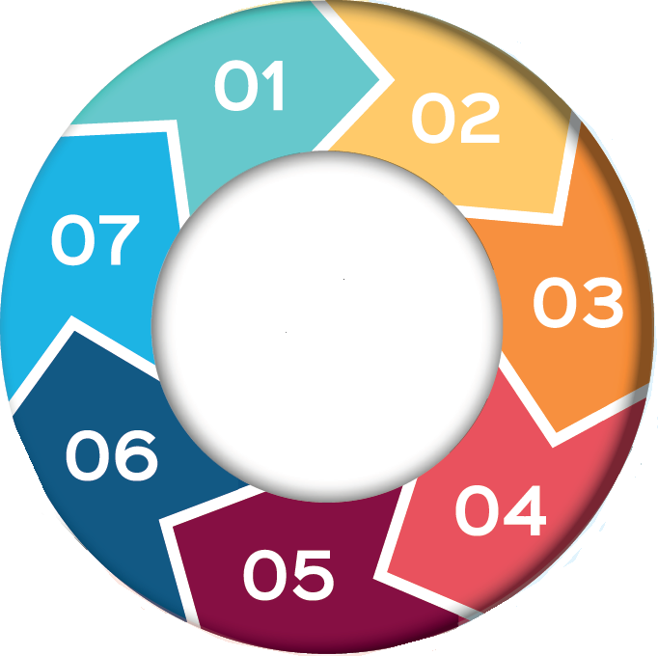
IRD
Interagency Referral
Discussion
7 Minute Briefing

6. Learning Opportunities

3

4.

5. Process and Recording

3. Who is Involved?

- What is an IRD?

An Inter-Agency Referral Discussion (IRD) is a formal multi-agency process used when there are concerns that a child, young person or unborn baby may be at risk of significant harm.
The core agencies involved are Social Work, Police, Health, Education and other relevant services included where appropriate.
The purpose of an IRD is to share information, assess risk, consider the child's lived experience and agree immediate actions to ensure the child's safety and wellbeing.

2. Why is an IRD Required?
An IRD is initiated when there is reasonable cause to suspect that a child may be at risk of significant harm.
This may arise from:
- A disclosure by a child or young person.
- Information received from a parent, carer or member of the public.
- Professional observations or concerns.
- Police investigations involving children.
- Pre-birth concerns where an unborn baby may be at risk following birth.
Acting early enables agencies to assess risk promptly and consider any protective actions required. Early discussion and information sharing are essential elements of effective child protection practice.

-
An IRD is initiated when there is reasonable cause to suspect that a child may be at risk of significant harm.
Acting early enables agencies to assess risk promptly and consider any protective actions required. Early discussion and information sharing are essential elements of effective child protection practice.

The core partners within an IRD are:
- Social Work
- Police
- Health
- Education
Depending on the circumstances, additional agencies may contribute.
Each agency contributes unique information about the child, family and wider circumstances, helping to build a fuller understanding of risk and protective factors.

Purpose and Outcomes
The purpose of an IRD is to bring agencies together to make informed decisions about a child's safety. The discussion ensures coordinated, timely and child-centred decision making.
An IRD may:
- Share relevant and up-to-date information.
- Assess immediate and longer-term risks.
- Consider the child's needs, experiences and circumstances.
- Decide whether a Joint Investigative Interview (JII) is required.
- Consider the need for a medical examination.
- Identify immediate protective measures.
- Agree next steps and ongoing support.
making.

IRDs are designed to happen quickly when concerns arise.
Key points include:
- All participating agencies contribute relevant information.
- Decisions and rationales are clearly recorded.
- Actions, responsibilities and timescales are agreed.
- Outcomes are communicated to relevant professionals.
Accurate recording is essential and provides a clear audit trail of decision-making and actions taken to safeguard the child/ren.

.

-

IRDs provide valuable learning opportunities for practitioners and agencies.
They help to:
- Strengthen professional curiosity and Improve understanding of risk indicators.
- Promote effective information sharing and enhance multi-agency collaboration.
- Support consistent decision-making. and keep the child at the centre of practice.
Learning from IRDs helps practitioners reflect on practice, develop their skills and strengthen professional judgement. It also contributes to continuous improvement across child protection services.

7. Why It Matters

Effective IRDs are a critical part of Scotland's child protection system.
By bringing agencies together at the earliest opportunity, IRDs:
- Improve communication and joint working.
- Support timely assessment of risk.
- Reduce the likelihood of significant harm.
- Ensure children receive the right support at the right time.
- Promote safer outcomes for children and families.

